Course Outcomes

CO-1 | Interpret the functional architecture of operating systems. (Understanding)  - Classify and study various OS implementation techniques.  - Understand how to implement system calls.  - Relate to fundamentals for file system implementation.  - Understand the basics of paging and segmentation and study advanced combination schemes based on them.  - Learn about various I/O devices and the I/O function.  - Appreciate process management functions like user/kernel level threads, multithreading, deadlock and process synchronization.  - List down the issues and ways to enforce system protection and security.
CO-2 | Identify, compare and assess issues related to process management, file systems and memory management. (Applying, Analyzing, Evaluating)  - Estimate the performance of various memory management techniques.  - Compare page replacement techniques.  - Analyze deadlock situations and suggest remedies.  - Evaluate advanced implementations like LFS and optimization for file system performance.
CO-3 | Design and analyze solutions in the area of operating systems. (Analyzing, Creating)  - Solve synchronization problems using synchronization tools like semaphores, monitors etc.  - Ability to add system calls to an OS.  - Ability to write multithreaded code.

Assessment of Attainment of Course Outcomes
Assessment Type | Course Outcome
 | CO-1 | CO-2 | CO-3
Final Exam | 40% | 30% | 30%
Assignments | 40% | 30% | 30%
Mid Sem Exams | 40% | 30% | 30%

Question Paper to CO mapping
Sessional 1 |  |  |  | Sessional 2 |  |  |  | End Semester
Q.No. | CO-1 | CO-2 | CO-3 | Q.No. | CO-1 | CO-2 | CO-3 | Q.No. | CO-1 | CO-2 | CO-3
1 | √ |  |  | 1 | √
2 |  | √ |  | 2 | √
3 | √ |  |  | 3 | √ | √ | √

UAD | MMD | ASM
Moderation Committee

Second Sessional Examination Winter 2017

Branch: 5th Sem, B.Tech. CSE Course: Operating Systems (CSL309)
Duration: 60 minutes Max. Marks: 15

Note: Attempt subparts of a question together. State the results and assumptions clearly. Draw neat diagrams wherever possible.

 | Consider a scenario wherein a sender process on one machine wants to transmit a packet via a network to a receiver process on another machine. Show the I/O software layers used and the various places where buffering happens. Supplement with a neat diagram as well. | 3
 | Answer the following briefly with proper justification  - Crash recovery cannot be optimized for Stable Storage if there is no non-volatile RAM. (True/False/Cannot Say).  - When is a segmented paging system desirable?  - If the logical geometry and the physical geometry of a disk differ then can we implement disk arm scheduling algorithms, and if so then where? | 3
 | - Assume a paging system that has a 20-bit virtual address with a 4 KB page size. Each Page Table entry contains 2 extra bits in addition to the essential translation information and the Page Table is stored in memory which is byte addressable and has a word size of 1 byte.  - Find the size of each Page Table if the system on which the processes run has a maximum physical memory of 1 GB.  - Calculate the size of Page Table assuming a different running system having 64 KB of physical memory.  - Suggest on how to use the physical memory (fully) for each of the above cases.  - Why and when is Buddy allocation preferred over paging?  A Buddy allocator is used to allocate 132 K of memory for the following requests in order: A=13.6K; B=30K; C=8K; A exits; C exits.  Write the pseudo code for the allocator and show by a neat diagram the allocated memory snapshot after each request. | 9

Solutions
1 | 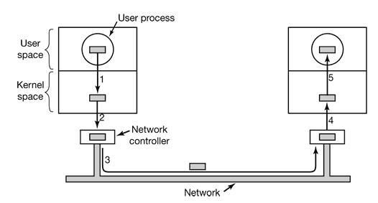
2 | False, can simulate it  Sparse address space  Yes, in the controller
3a | - No. of entries =256 20-12=8, bits for frame no. =30-12=18, per entry=18+2=20 bits or 3 bytes  Size= 256*3=768bytes  - Bits for frame no.=16-12=4, per entry=4+2=6bits or 1 byte, size=256bytes  - Multiprogramming, Virtual memory
3b | Less internal fragmentation, contiguous memory

